

**St.Montfort Sr. Sec. School**

**Patel Nagar, P.B.No.16, Piplani P.O. Bhopal**

**COMPUTER SCIENCE PROJECT**

**ON**

**MARRIAGE BUREAU SYSTEM**

**FOR**

**THE PARTIAL FULFILLMENT OF**

**AISSCE –2021 – 22 : TERM 2**

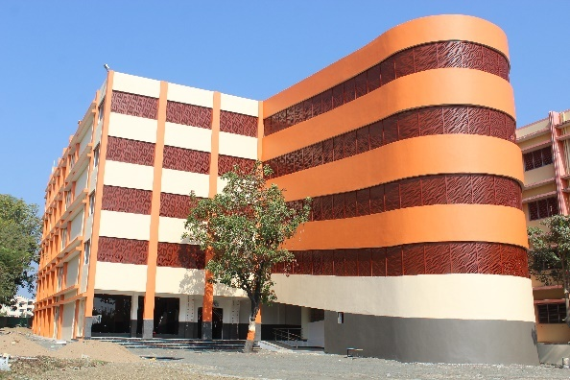

**Submitted By:**

**Purvesh Patil**

**INDEX**

**S.No. Section Page No.**

**1 Certificate 3**

**2 Acknowledgements 4**

**3 Declaration 5**

**4 Introduction to Project 6**

**5 Programming Language used 7**

**6 Backend tool used 8**

**7 Concepts used 11**

**8** **Menus/Options provided** **15**

**9 Program Code 16**

**10 Output 21**

**11 Conclusion 27**

**12 Bibliography 28**

**CERTIFICATE**

This is to certify that Mast./Miss. Purvesh Patil has successfully completed this project report entitled MARRIAGE BUREAU SYSTEM during the academic year 2021-22 towards the partial fulfilment of Computer Science Practical Examination for AISSCE 2021-22, conducted by CBSE.

**Principal**

**__________________________________________**

**Internal Examiner External Examiner**

**_________________________ ________________________**

**Acknowledgements**

I would like to express my special thanks of gratitude to our Principal Rev. Bro. Monachan K.K., who gave me the golden opportunity to accomplish this project work of Computer Science.

I would also like to thank my teacher Ms. Gargee Chattopadhyay for suggesting this topic to me. I am especially thankful to my fellow group members who helped me in completing my project. I came to learn many new concepts and developed logical thinking.

At last, I also would like to thank my parents and friends who helped me in finalizing and completing the project within the stipulated timeframe.

Purvesh Patil

**Declaration**

I, Purvesh Patildo here by declare that the Assignment File in Python is a bona fide work done by me and was under the guidance of

Ms. GARGEE CHATTOPADHYAY, also declare this assignment or any part of it has not been submitted by me fully or partially for any other examination before.

Place: St. Montfort Sr. Sec. School

Date: 01/03/2022

**PROJECT ON CREATING MARRIAGE BUREAU SYSTEM**

**Introduction**

This program helps the users in providing their details to the software.

This also helps the user in searching for a suitable bride/groom on the basis of Profession and also on basis of appearance.

Once we fill the search Column automatically the software will fetch the related data available and displays it.

The user can use the registration number to view the registered details.

This program can be used only if the Login ID and the Password are correct.

This prevents a lot of time and money. The work becomes fully automated and any information regarding the organization can be obtained by clicking the button. Moreover, now it’s an age of computers of and automating such an organization gives the better look.

**Programming Language used**

**Python 3.9.0**

* Python is an interpreted, object-oriented, high-level programming language with dynamic semantics.
* Python’s simple, easy to learn syntax emphasizes readability
* And therefore reduces the cost of program maintenance.
* Python supports modules and packages, which encourages program modularity and code reuse.
* Python 3.9 is the latest version providing those Python2 backward compatibility layers, to give more time to python projects maintainers to organise the removal of the Python2 support and add support for Python 3.9.

**What’s New in Python 3.9**

1. Relaxed grammar restrictions on decorators.
2. String methods to remove prefixes and suffixes.
3. Flexible function and[variable](https://www.fireblazeaischool.in/blogs/variables-in-python/) annotations.
4. Fast access to module state from methods of C extensiontypes.CPython now uses a new parser based on PEG.
5. A number of Python built-ins (range, tuple, set, frozenset, list, dict) are now sped up using vector call.

**Backend tool used**

**Visual Studio code**

Version 1.16

Visual Studio Code is a streamlined code editor with support for development operations like debugging, task running, and version control. It aims to provide just the tools a developer needs for a quick code-build-debug cycle and leaves more complex workflows to fuller featured IDEs.

Visual Studio Code is an excellent editor for students and other learners just getting started with programming.

The extension makes Visual Studio Code an excellent Python editor, and works on any operating system with a variety of Python interpreters.

**MY SQL**

MySQL is a relational database management system (RDBMS) developed by Oracle that is based on structured query language (SQL).

A database is a structured collection of data. It may be anything from a simple shopping list to a picture gallery or a place to hold the vast amounts of information in a corporate network. In particular, a relational database is a digital store collecting data and organizing it according to the relational model. In this model, tables consist of rows and columns, and relationships between data elements all follow a strict logical structure. An RDBMS is simply the set of software tools used to actually implement, manage, and query such a database.

Because MySQL enjoys the most widespread use in many industries, business users from new webmasters to experienced managers should strive to understand its main characteristics. Deciding whether to use this technology, and communicating about it effectively, starts with a review of MySQL’s basic availability, structure, philosophy, and usability.

MySQL is widely compatible

Though often associated with internet applications or web services, MySQL was designed to be extensively compatible with other technologies and architectures. The RDBMS runs on all major computing platforms, including Unix-based operating systems, such as the myriad Linux distributions or Mac OS, and Windows.

MySQL’s client-server architecture means it can support a variety of backends, as well as different programming interfaces. Data can be directly migrated from MySQL to its forks (e.g. MariaDB), as well as most other RDBMSs thanks to architectural and language similarities.

Established Oracle and third-party migration tools further allow MySQL to move data to and from a vast set of general storage systems, whether these are designed to be on-premises or cloud-based. MySQL can be deployed in virtualized environments, distributed or centralized, and even exists as portable standalone libraries for learning purposes, testing, or small applications.

**Concepts used**

**Functions**

A function is a block of code which only runs when it is called.

We can pass data, known as parameters, into a function.

A function can return data as a result.

Information can be passed into functions as arguments.

Arguments are specified after the function name, inside the parentheses.

We can add as many arguments as you want, just separate them with a comma.

By default, a function must be called with the correct number of arguments. Meaning that if our function expects 2 arguments, we have to call the function with 2 arguments, not more, and not less.

We can send any data types of argument to a function (string, number, list, dictionary etc.), and it will be treated as the same data type inside the function.

**File Handling**

Python too supports file handling and allows users to handle files i.e., to read and write files, along with many other file handling options, to operate on files.

The concept of file handling has stretched over various other languages, but the implementation is either complicated or lengthy, but alike other concepts of Python, this concept here is also easy and short.

Python treats file differently as text or binary and this is important. Each line of code includes a sequence of characters and they form text file.

Each line of a file is terminated with a special character, called the EOL or End of Line characters like comma {,} or newline character. It ends the current line and tells the interpreter a new one has begun.

Python provides inbuilt functions for creating, writing and reading files. There are two types of files that can be handled in Python, normal text files and binary files (written in binary language, 0s and 1s).

1. Text files: In this type of file, Each line of text is terminated with a special character called EOL (End of Line), which is the new line character (‘\n’) in Python by default.
2. Binary files: In this type of file, there is no terminator for a line and the data is stored after converting it into machine-understandable binary language.

**MY SQL CONNECTIVITY**

A connection is a computer science facility that allows the user to connect with the database server software. A user can connect with the database server, whether on the same machine or remote locations. Therefore, if we want to work with the database server to send commands and receive answers in the form of a result set, we need connections.

MySQL command-line client program provides interaction with the database server in an interactive and non-interactive mode.

When used interactively, query results are presented in an ASCII-table format. When used noninteractively (for example, as a filter), the result is presented in tab-separated format. The output format can be changed using command options.

**Menus/Options provided**

* REGISTER
* LOGIN

**Enter your choice:**

**Enter your Username:**

**Enter your Password:**

* provide details
* Loans and Advances
* in search of bridegroom
* Male customer details
* Female customer details
* Handsome Bride
* Beautiful Groom

**Program Code**

from prettytable import from_db_cursor

import mysql . connector as sql

conn=sql.connect(host='localhost',user='root',passwd='1234',database='marriage_bureau_system')

cur = conn.cursor()

print('*****************************************************MARRIAGE BUREAU SYSTEM**************************************************')

print('1.REGISTER')

print('2.LOGIN')

n=int(input('Enter your choice:'))

if n== 1:

name=input('Enter your User name:')

passwd=int(input('Enter your Password(only numbers):'))

print()

V_SQLInsert="INSERT INTO user_id (password,user_name) values (" + str (passwd) + ",' " + name + " ') "

cur.execute(V_SQLInsert)

conn.commit()

print()

print('USER created succesfully')

if n==2 :

name=input('Enter your Username=')

print()

passwd=int(input('Enter your Password='))

V_Sql_Sel="select * from user_id where password='"+str (passwd)+"' and user_name= ' " +name+ " ' "

cur.execute(V_Sql_Sel)

if cur.fetchone() is None:

print()

print('Invalid username or password')

else:

print()

import py

conn=sql.connect(host='localhost',user='root',passwd='1234',database='marriage_bureau_system')

if conn.is_connected():

c1=conn.cursor()

print('________________________________________________________________WELCOME TO MARRIAGE BUREAU SYSTEM _______________________________________________________')

c='y'

while c.lower()=='y':

print('=======================')

print("1.provide details")

print('2.in search of bride/groom')

print('3.Loans and Advances')

choice=int(input('enter the choice:'))

if choice==1:

print('==========================')

print('6.Male customer details')

print('7.Female customer details')

choice=int(input('enter the choice:-'))

if choice==2:

print('========================')

print('4. Handsome Groom ')

print('5. Beautiful Bride ')

choice=int(input('enter the choice-'))

if choice==3:

print('========================')

print('8.Take marriage loan')

print('9.Terms and conditions')

choice=int(input('enter the choice:-'))

if choice == 6:

a=(input('enter the name:'))

b=(input('enter the address:'))

c=(input('enter the caste:'))

d=(input('enter the appreance:'))

e=(input('enter the age:'))

f=(input('enter the profession:'))

g=(input('enter the phone_no:'))

c1=conn.cursor()

sql_insert="insert into legends_details values( '{}','{}','{}','{}','{}','{}','{}')".format(a,b,c,d,e,f,g)

c1.execute(sql_insert)

conn.commit()

print ('Data inserted')

c=input('do you want to continue (y/[n]:)')

if c =='y' :

continue

else:

print('THANK YOU FOR VISITING OUR WEBSITE' )

print('VISIT AGAIN')

if choice==7:

h=(input('enter the name:'))

i=(input('enter the address:'))

j=(input('enter the caste:'))

k=(input('enter the appreance:'))

l=(input('enter the age:'))

m=(input('enter the profession:'))

n=(input('enter the phone_no:'))

c1=conn.cursor()

sql_insert="insert into girls_details values( '{}','{}','{}','{}','{}','{}','{}')".format(h,i,j,k,l,m,n)

c1.execute(sql_insert)

conn.commit()

print("Details are successfully inserted")

c=input('do you want to continue (y/[n]:)')

if c =='y' :

continue

else:

print('THANK YOU FOR VISITING OUR WEBSITE' )

print('VISIT AGAIN')

if choice==4:

prof=(input('Enter the profession:'))

c1.execute("select* from legends_details where profession='{}'". format(prof))

x = from_db_cursor(c1)

print(x)

c=input('do you want to continue (y/[n]:)')

if c =='y' :

continue

else:

print('THANK YOU FOR VISITING OUR WEBSITE' )

print('VISIT AGAIN')

print()

break

if choice==5:

appearence=(input('Enter the appearence:'))

c1.execute("select* from girls_details where appearence='{}'". format(appearence))

x = from_db_cursor(c1)

print(x)

c=input('do you want to continue (y/[n]:)')

if c =='y' :

continue

else:

print('THANK YOU FOR VISITING OUR WEBSITE' )

print('VISIT AGAIN')

print()

break

if choice==8:

h=(input("Enter your name:"))

j= (input("Enter the amount of loan to be taken: "))

k= (input("Enter your bank Accountnumber: "))

c1=conn.cursor()

sql_insert="insert into loans values( '{}','{}','{}')".format(h,j,k)

c1.execute(sql_insert)

conn.commit()

print("The loan has been issued check your email for further updates")

c=input('do you want to continue (y/[n]:)')

if c =='y' :

continue

else:

print('THANK YOU FOR VISITING OUR WEBSITE' )

print('VISIT AGAIN')

if choice==9:

print("Terms And Conditons Are:")

print("1. You are eligible for a Personal Loan for Wedding if you are a salaried person")

print("2. aged 21-58 years with two years of work experience")

print("3. Our interest rates that start at 10% ")

print("4. You should be in the present organisation for at least six months with a salary of ₹ 20,000 per month.")

print("5. Maximum Rs.20 lakh of loan can be taken")

**Output**

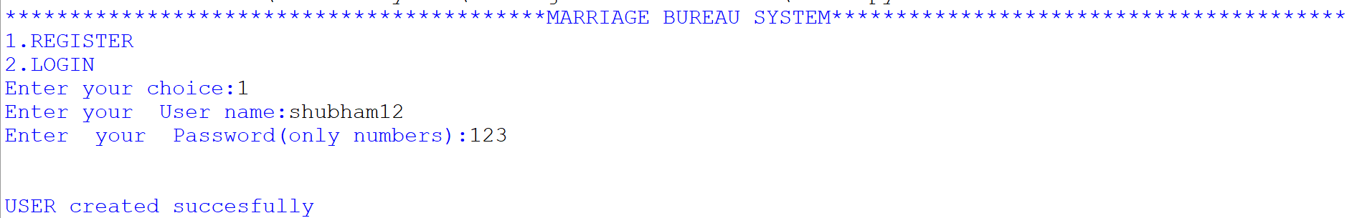1) Registering a new user:-

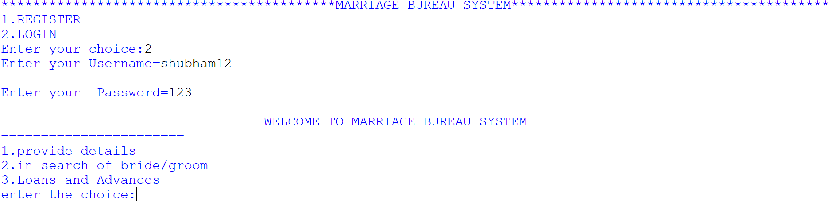2) Login Screen:-

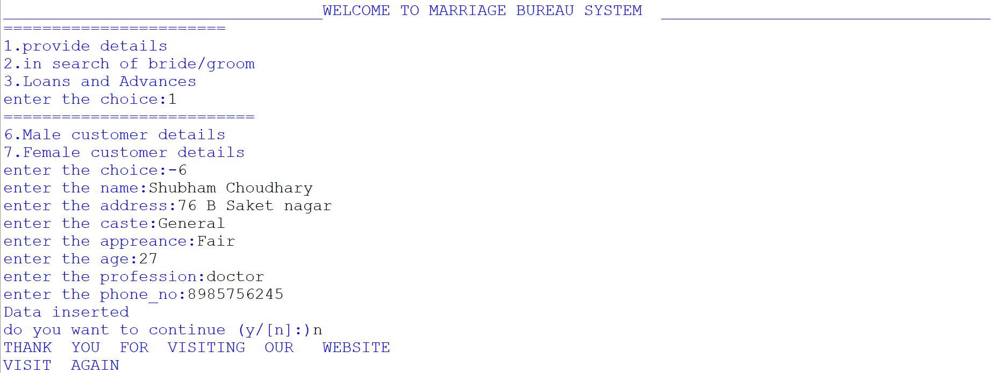3) Providing Male Customer Details:-

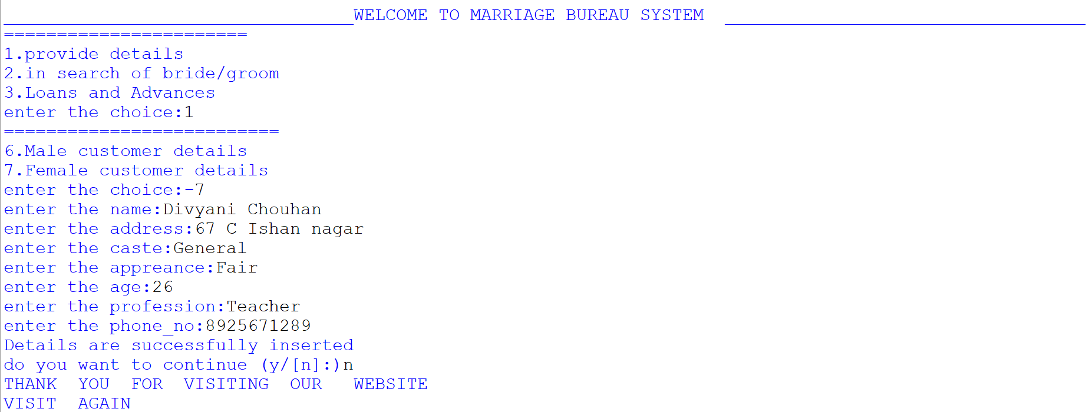4) Providing Female Customer Details:-

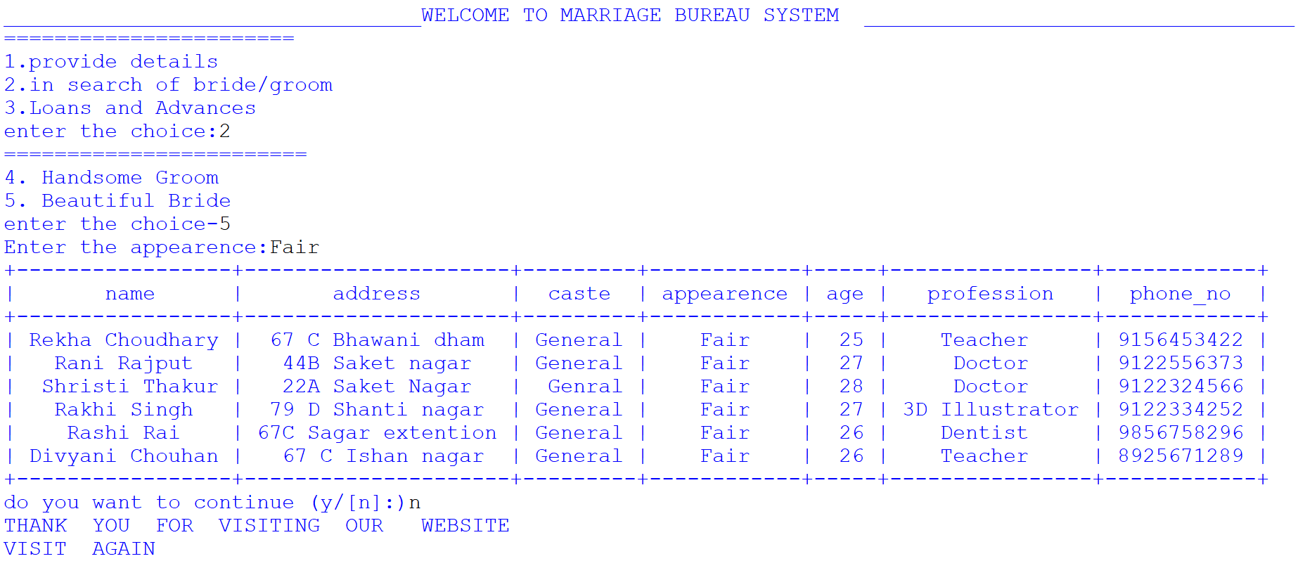5) Searching For Bride:-

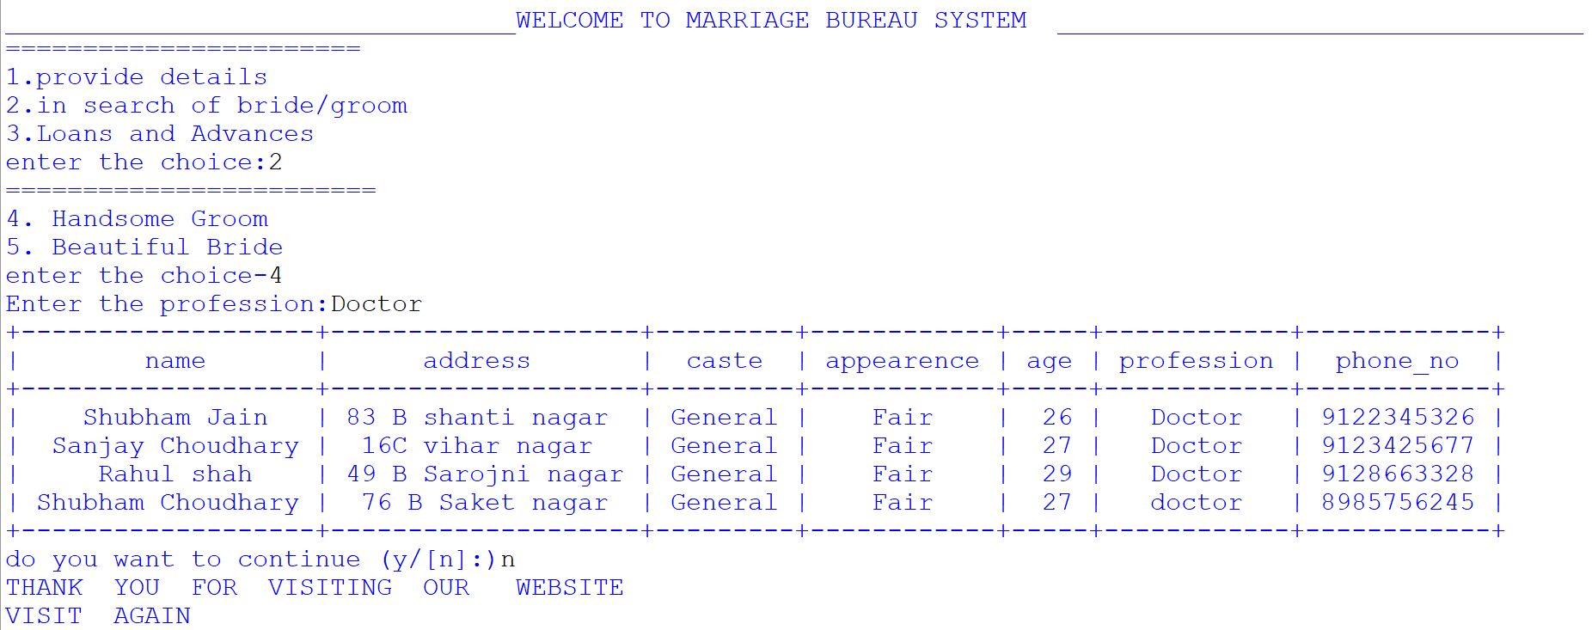6) Searching For Groom:-

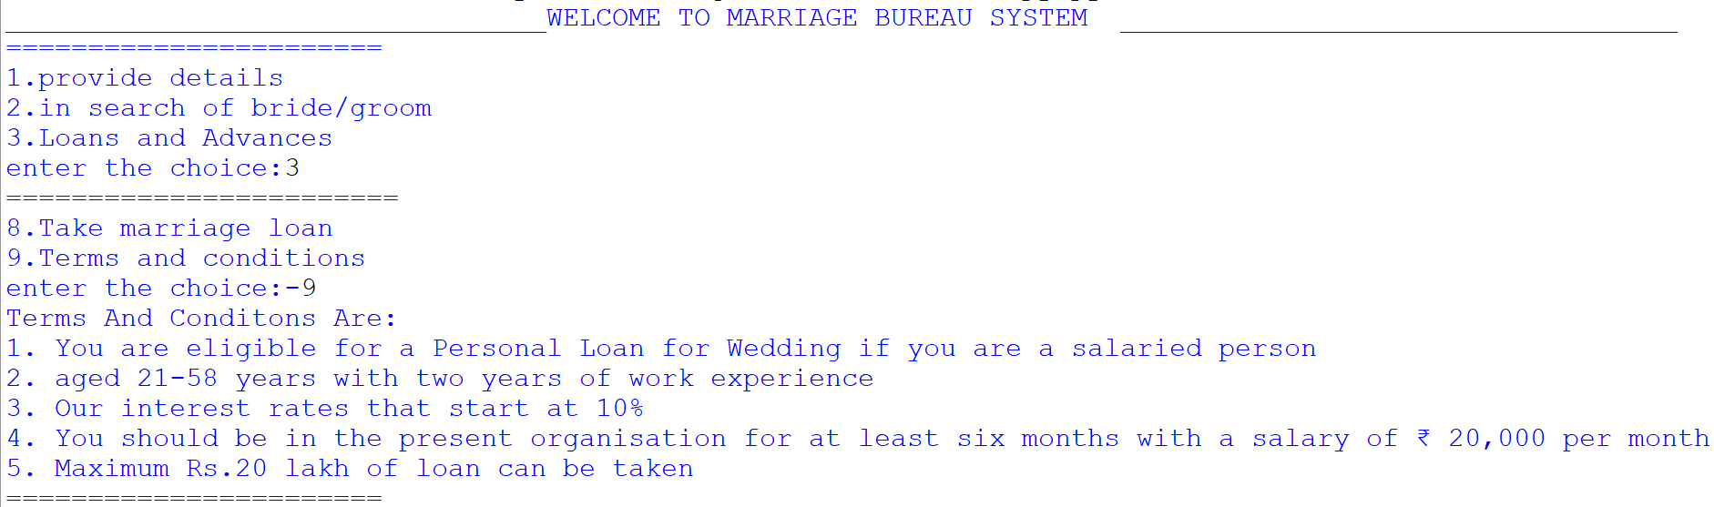7) Terms And Conditions For Taking A Loan:-

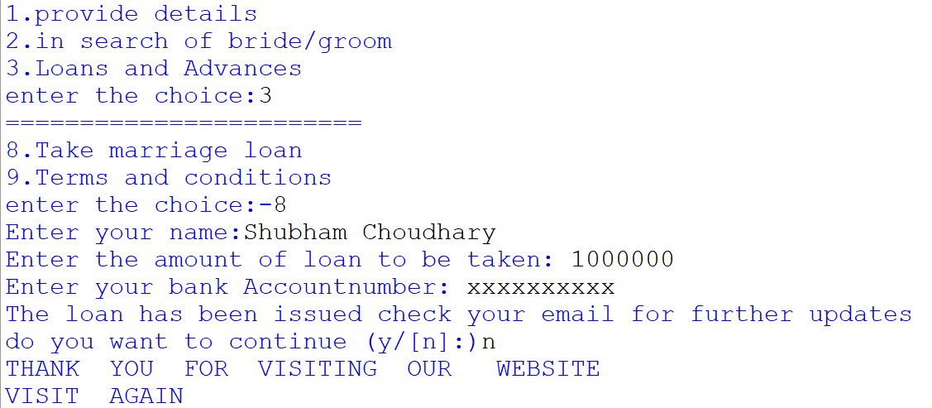8) Taking A Marriage Loan:-

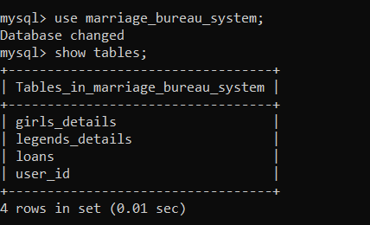9) MYSQL Tables:-

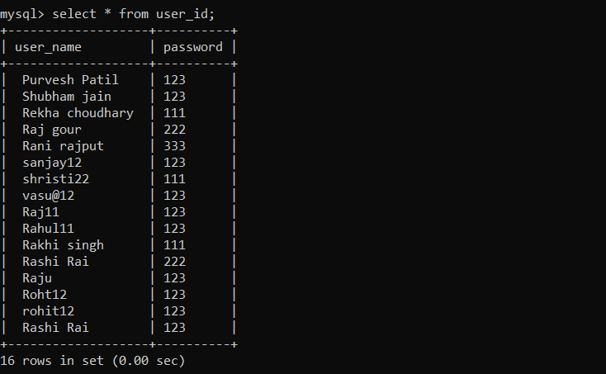

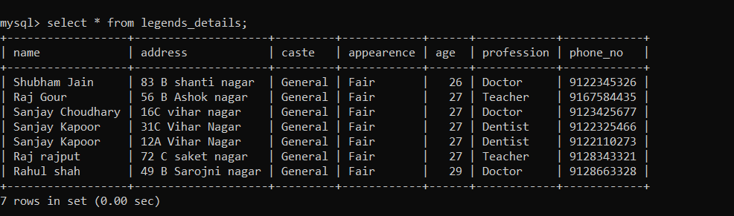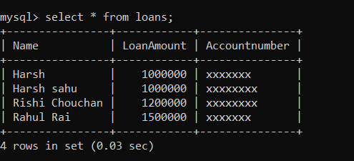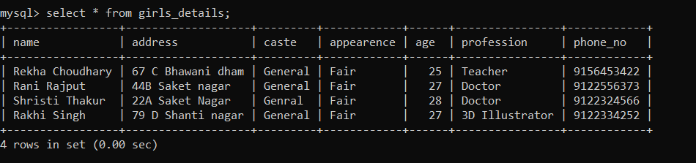

**Conclusion**

The objective of this project is to let the students apply the programming knowledge into a real- world situation/problem and exposed the students how programming skills helps in developing a good software.

1. Write programs utilizing modern software tools.

2. Apply object oriented programming principles effectively when developing small to medium sized projects.

3. Write effective procedural code to solve small to medium sized problems.

4. Students will demonstrate a breadth of knowledge in computer science, as exemplified in the areas of systems, theory and software development.

5. Students will demonstrate ability to conduct a research or applied Computer Science project, requiring writing and presentation skills which exemplify scholarly style in computer science.

**Bibliography**

1. Computer Science with python by sumita arora, Dhanpat Rai Publications.

2. https://www.geeksforgeeks.org/